ACKNOWLEDGEMENT

My sincere thanks to Prof. (Dr.) Sanjay Kuanar, Head of the Department of CSE ,Gandhi Institute of Engineering and Technology, Gunupur for his encouragement and valuable suggestions during period of my project work.

No words would suffice to express my regard and gratitude to Prof. Ranjeet Panigrahi, Department of CSE, GIET , Gunupur for his inspiring guidance, constant encouragement, immense support and help during the course of the project.

I express my heartfelt gratitude to Principal, GIET, Gunupur for permitting me to carry out this project work.

CONTENTS

1. Abstract

2. Introduction

  - Purpose

  - Project Scope

  - Product Features

3. System Analysis

  - User Requirements (SRS)

  - Hardware Requirements

  - User (Questionnaires)

4. System Design & Specifications

High Level Design (HLD)

- Project Model

- Structure Chart

- DFD

- UML ( Use Case )

Low Level Design (LLD)

  - Process Specification ( Pseudo code / Algorithm )

  - Screen-Shot Diagram

5. TESTING

6. CONCLUSION

7. REFERENCE /BIBLIOGRAPHY.

ABSTRACT

Many people have experienced going to a restaurant where the service is poor and there is a lack of attention from the wait staff. The paper menus can be flimsy, hard to navigate, and outdated. To leverage the growing mobile industry, the solution we have developed uses mobile devices in order to interact more with customers. This restaurant menu and management system will replace the paper waste, is more maintainable, and allows for greater customer engagement.

This project consists of the development of the mobile app and a site designed for this system. A particular focus for this project was on user interface design and how Wi-Fi Direct can be used with such a system. This project has provided good insight and experience in the development of user interfaces for mobile app, site and the key design issues that must be considered. Wi-Fi Direct was successfully used to allow mobile device and manager site to communicate and manage information between them, but some limitations discovered may not make it an ideal solution.

Assumptions & Constraints:

The system assumes the following:
1. The details provided by the customer are correct.
2. The item in menu, payment mode entered by the customer are correct.
3. The customer can view only the Faults created by their own.
4. The manager can view all the Faults.
5. The remarks updated by the manager are true.

Customer Characteristics:

Customer:

The Customers of Avishmya, who are in the restaurant are the Customers. Customers can View the Profile.

Managers:

The Employees of the Avishmya, Managers can View/ Update Remarks for all the Open Faults posted. Managers can delete the closed faults.

INTRODUCTION

1.1Purpose
Visiting a restaurant traditionally involves selecting a meal from a paper menu and being waited on by the restaurant's wait staff. A busy restaurant or inattentive staff can leave customers waiting to have their orders taken, drinks refilled or to receive their bill. If the restaurant is busy the customer is left occupying a table longer than they need leaving other customers waiting. Any unnecessary waiting can reduce customer satisfaction and ultimately result in lost business.

To reduce customer wait times, management must ensure sufficient staff is present during peak hours and that they are properly trained to provide excellent customer service. These staffing issues can lead to substantial costs for the business.

Paper menus are problematic. The restaurant may have a large number of menu items which can make the menu appear overwhelming to look through. As a result, customers may not see all the items they would have been interested in. When changes to the menu are required, such as price adjustments or item updates, the costs and environmental concerns associated with reprinting need to be considered.
Menu changes are often left to accumulate until enough are required to justify the costs of reprinting. Changes may be required frequently and a paper menu would quickly become outdated. Waiting until a reprint is done before implementing the changes in the restaurant may not be a sound business practice. Manually updating menus instead of reprinting can lead to inconsistencies and may make the restaurant appear cheap and low quality.
We have designed and built a restaurant menu and management system that provides an interactive android based menu that replaces the paper menu entirely and removes much of the need to be waited on by the restaurant's wait staff. This restaurant based menu app also provides additional features designed to enhance the customer's overall experience. A separate management site allows the restaurant's management to quickly make changes to the menu and provide a snapshot of the restaurant at any given time. The restaurant menu and management system consists of the menu app, the management site, the server and a database. The development of this system was decomposed into two independent projects: the menu app and management site; and the server and database. This report covers the development of the menu app and management site.

1.2 Scope

The purpose of the Avishmya is to create convinient and easy-to-use digital order system for customer to order their food. The system is based on an Menu app and a Management site which is connected by each other through localhost and relational database. We will have a database supporting dozens of customer order from all the tables simultaneously. Above all, we hope to provide a comfortable customer experience along with the best problem resolving facilities.

1.3 FEATURES

There are two different customers who will be using this product.
- Customer who will be using Avishmya services.
- Agent who is the employee of Avishmya.

1.4 HOW TO USE?
The customers of Avishmya will get an Android App in which they can see the menu list, about restaurant. Instead of giving order by paper menu we are using it digitally through Menu app.
First the customer will get a Login Code which they have to enter at the first page of app to go inside the app and able to view the menu and table number. Then the customer has to entry his name, total number of persons with him/her and have to select seat. Then the customer will select the item according to their wish and can select “Show Order” to view his own order. Then after selecting “Confirm” button the order will directly go to the Manager’s site which he is handling there. After everything customer can pay through app also.
Manager can update the contents of menu. He also handles the service provided by his restaurant and keep updating every customer about their food details. Manager can also view the whole day profit, number of customers etc.

SYSTEN ANALYSIS

3.1 Hardware Interface

- 1 GB (32 Bit) or 2 GB (64 Bit) RAM .
- 3GB of available hard disk space.
- 5400 RPM hard disk drive.
- DirectX 9 capable video card running at 1024 x 768 or higher-resolution display.
- DVD-ROM Drive.
- Computer that has a 1.6GHz or faster processor.
- Smartphone having Android above 5.1 version.

3.2 USER REQUIREMENTS (SRS):

- Operating system : Android 5.1(and above)

Windows 7/8.1/10
- Programming specification : JSP
- Web server : Oracle XE
- Platform : Android

3.3 Supporting Browsers:
- Google chrome, Internet explorer, Mozilla Firefox, Opera.

3.4 USERS (QUESTIONNARIES):

Questionnaries are extremely important because the software affects how effective the questionnaire will be, and how easy it will be for you to create it. Each questionnaire is designed to capture what is ideally a truthful answer- a data point that you can use to make decisions. A list of questions that the users will want to know while software develop is:
- How frequently is the software updated?
- Who are the primary users of the product, and what is their technical level?
- What’s the environment in which this product will be used?

3.5 TECHNOLOGIES USED:

- ORACLE XE:
Oracle XE is a relational database management system developed by Microsoft. As a database server, it is a software product with the primary function of storing and retrieving data as requested by other software applications—which may run either on the same computer or on another computer across a network (including the Internet).
Microsoft markets at least a dozen different editions of Microsoft SQL Server, aimed at different audiences and for workloads ranging from small single-machine applications to large Internet-facing applications with many concurrent users.

- Android:

Android is a mobile operating system developed by Google, based on the Linux kernel and designed primarily fortouchscreen mobile devices such as smartphones and tablets. Android's user interface is mainly based on direct manipulation, using touch gestures that loosely correspond to real-world actions, such as swiping, tapping and pinching, to manipulate on-screen objects, along with a virtual keyboard for text input. In addition to touchscreen devices, Google has further developed Android TV for televisions, Android Auto for cars, and Android Wear for wrist watches, each with a specialized user interface. Variants of Android are also used on notebooks, game consoles, digital cameras, and other electronics.
Android has the largest installed base of all operating systems (OS) of any kind. Android has been the best selling OS on tablets since 2013, and on smartphones it is dominant by any metric.
Initially developed by Android, Inc., which Google bought in 2005, Android was unveiled in 2007 along with the founding of the Open Handset Alliance – a consortium of hardware, software, and telecommunication companies devoted to advancingopen standards for mobile devices. As of July 2013, the Google Play store has had over one million Android applications ("apps") published – including many "business-class apps" that rival competing mobile platform. – and over 50 billion applications downloaded. An April–May 2013 survey of mobile application developers found that 71% of developers create applications for Android, and a 2015 survey found that 40% of full-time professional developers see Android as their priority target platform, which is comparable to Apple's iOS on 37% with both platforms far above others. In September 2015, Android had 1.4 billion monthly active devices.
Android's source code is released by Google under open source licenses, although most Android devices ultimately ship with a combination of open source and proprietary software, including proprietary software required for accessing Google services. Android is popular with technology companies that require a ready-made, low-cost and customizable operating system for high-tech devices. Its open nature has encouraged a large community of developers and enthusiasts to use the open-source code as a foundation for community-driven projects, which deliver updates to older devices, add new features for advanced users or bring Android to devices originally shipped with other operating systems. The success of Android has made it a target for patent (and copyright) litigation as part of the so-called "smartphone wars" between technology companies.

- JSP (JavaServer Pages)

JavaServer Pages (JSP) is a technology that helps software developers create dynamically generated web pages based on HTML, XML, or other document types. Released in 1999 by Sun Microsystems, JSP is similar to PHP, ASP and React's JSX but it uses the Java programming language.
To deploy and run JavaServer Pages, a compatible web server with a servlet container, such as Apache Tomcat or Jetty, is required.

SYSTEM DESIGN AND SPECIFICATION

The restaurant menu and management system is composed of several different components. The two components developed for this project are the menu app and management site. A REST architecture style is used to provide communication between the app and site components and the system's server component. Device-to-device communication between menu apps is accomplished through Wi-Fi Direct. The server connects to the database to retrieve and store the restaurant's menu, customer and business data (See Figure 1).

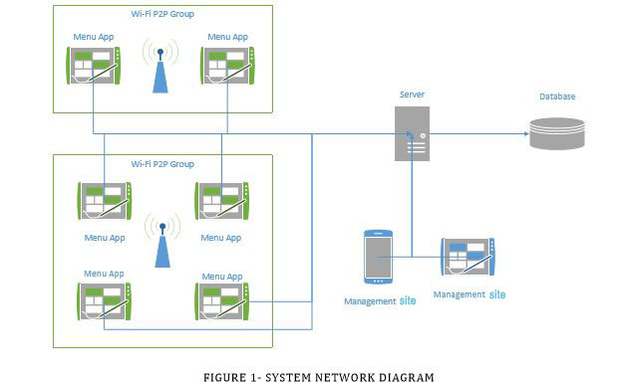

System design involves the development of logical and physical for an information system that meets the system requirements developed by the system analysis process. System design involves the detailed design of input documents, output, reports, database and processing procedure. Analysis phase focus on what needs to be done independent of how it done. During design decisions are made about, how the problem will be solved? The design process is performed through the following phases:

- Class diagram
- USE CASE diagram

USE CASE DIAGRAM:

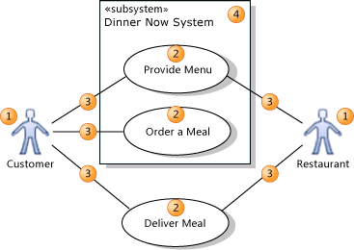

3.2 Analysis view :

Class Diagram

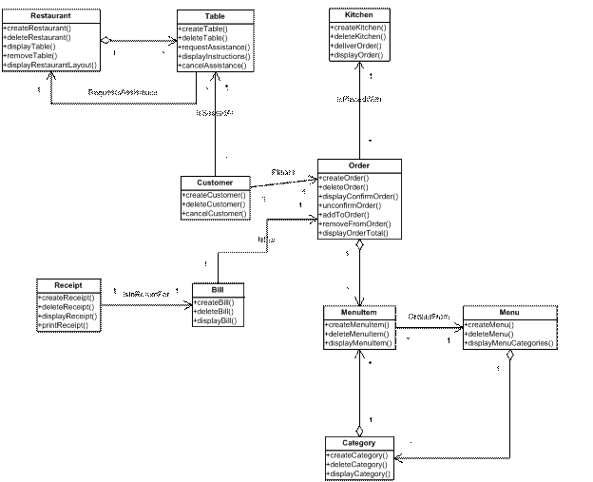

3.3Structure chart

AGENT STRUCTURE CHART:

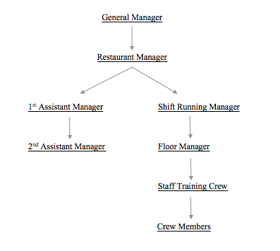

3.4 ER DIAGRAM:

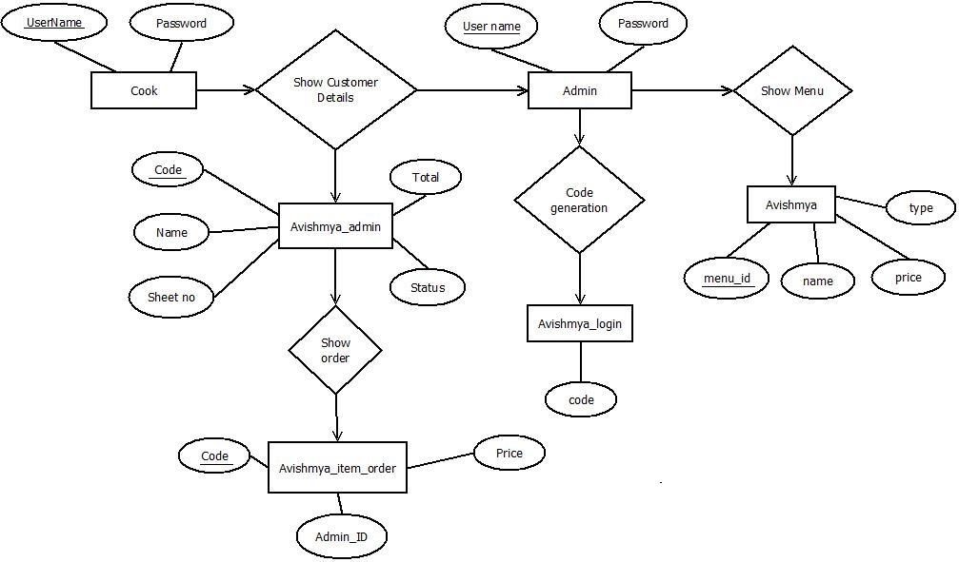

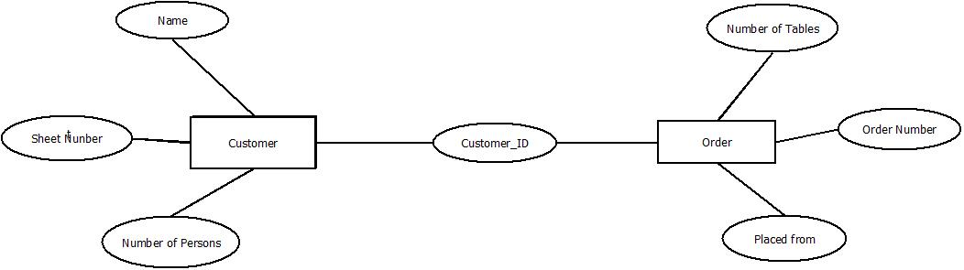

3.5 DATA FLOW DIAGRAM (DFD):

LEVEL 0 DFD:

0

Avishmya

CUSTOMER

ORDERS

MANAGER

LEVEL 1 DFD:

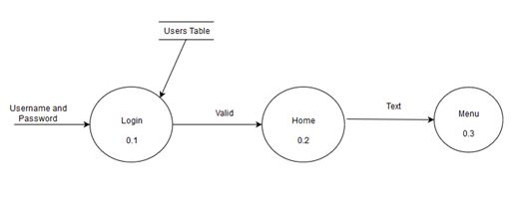

LEVEL 2 DFD:

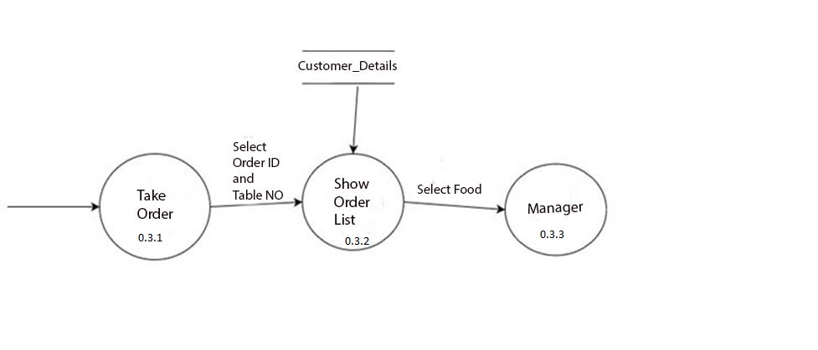

4.2 LOW LEVEL DESIGN(LLD):

4.2.1 PROCESS SPECIFICATION(CODE):

CODING:

The purpose of the coding and unit testing phase of software development is to translate the software design into sourse code and test each module in isolation as this is the best way to debug the errors identified at this stage.

Sample Of Some Codes:-

1. FOR Manager Home Page:

<!DOCTYPE html>
<html lang="en">
<head>
<title>Avishmya</title>
<meta charset="utf-8">
<link rel="stylesheet" type="text/css" media="screen" href="css/reset.css">
<link rel="stylesheet" type="text/css" media="screen" href="css/style.css">
<link rel="stylesheet" type="text/css" media="screen" href="css/slider.css">
<link href='http://fonts.googleapis.com/css?family=Great+Vibes' rel='stylesheet' type='text/css'>
<script src="js/jquery-1.7.min.js"></script>
<script src="js/jquery.easing.1.3.js"></script>
<script src="js/tms-0.4.1.js"></script>
<script>
$(document).ready(function(){
$('.slider')._TMS({
show:0,
pauseOnHover:true,
prevBu:false,
nextBu:false,
playBu:false,
duration:700,
preset:'fade',
pagination:true,
pagNums:false,
slideshow:8000,
numStatus:false,
banners:false,
waitBannerAnimation:false,
progressBar:false
})
});
</script>
<!--[if lt IE 9]>
<script src="js/html5.js"></script>
<link rel="stylesheet" type="text/css" media="screen" href="css/ie.css">
<![endif]-->
</head>
<body>
<div class="bg-top">
<div class="bgr">
<!--==============================header=================================-->
<header>
<div>
<h1><a href="index.html"><img src="images/logo.jpg" alt=""></a></h1>
</div>
<nav>
<ul class="menu">
<li class="current"><a href="index.html">Restaurant</a></li>
<li><a href="menu.html">Menu</a></li>
<li><a href="manager.html">Manager</a></li>
<li><a href="cook.html">Cook</a></li>
<li><a href="gallery.html">Gallery</a></li>
<li><a href="contacts.html">Contacts</a></li>
</ul>
<div class="clear"></div>
</nav>
<div id="slide">
<div class="slider">
<ul class="items">
<li><img src="images/slider-1.jpg" alt=""></li>
<li><img src="images/slider-2.jpg" alt=""></li>
<li><img src="images/slider-3.jpg" alt=""></li>
</ul>
</div>
<div class="phone-number">Call us for reservation:<strong>7205739943</strong></div>
</div>
</header>
<!--==============================content================================-->
<section id="content">
<div class="block-1">
<div class="border-right">
<div class="block-1-title"> <span>01.</span>
<div class="text-1">Best<strong>cuisine</strong></div>
<strong class="clear"></strong> </div>
<p class="border-1">Chinese cuisine is a popular cuisine among a number of food lovers. It comprises of styles initiated from the various parts of China and also from the Chinese scattered across the globe. The Chinese staple food comprise of noodles, rice, sauces, vegetables & seasonings. Cantonese, Anhui, Jiangsu, Hunan, Szechuan, Shandong & Zhejiang are some of the regional cuisines. In the Cantonese Chinese regional cuisine the traditional cooking procedures such as steaming, stewing, frying are utilized.</p>
<a href="#" class="link-1">read more</a> </div>
<div class="border-right">
<div class="block-1-title"> <span>02.</span>
<div class="text-2">Good<strong>rest</strong></div>
<strong class="clear"></strong> </div>
<p class="border-1">Good Rest is very necessary to keep body fit. And we are providing you that. We have a comfortable seat so you can relaxe on it and have you food with great ease. Because we believe in only one thing that "Having a good rest for some time, keeps you happy for whole day". So come with your family, take your food with one of the great restaurant with great ease and confort. We have great number of dishes with its unique flavour which you will not get anywhere except our hotel. So do come with your family. Its our honour if you come.</p>
<a href="#" class="link-1">read more</a> </div>
<div class="border-right">
<div class="block-1-title"> <span>03.</span>
<div class="text-3">Great<strong>service</strong></div>
<strong class="clear"></strong> </div>
<p class="border-1">We all know that good customer service is crucial, but once you get down to trying to define what goes into it, not everyone is on the same page. To some, good customer service is as simple as solving problems and offering solutions in an expedient manner. To others it means overall pleasantness and politeness from those who represent the frontlines of the company.Others define it as when a company is willing to give their customers anything and everything that they want the customer is always right approach.</p>
<a href="#" class="link-1">read more</a> </div>
<div class="block-1-last">
<div class="block-1-title"> <span>04.</span>
<div class="text-4">Best<strong>cooks</strong></div>
<strong class="clear"></strong> </div>
<p class="border-1">The competition began with 16 chefs, four from each region of the north, south, east, and west. They were each mentored by a mentor from their region. Michael Symon mentored the north, Cat Cora helped the south, Tyler Florence mentored the west, and Alexandra Guarnaschelli helped out the east. After week 1, 8 chefs were eliminated and after that they went one by one until the final four reached the finale. In each week, they had special challenges which were served by a guest judge. </p>
<a href="#" class="link-1">read more</a> </div>
</div>
<div class="block-2 pad-1">
<div class="col-1">
<h2 class="h2-line">We are glad to invite you!<strong>The place where you feel bliss</strong></h2>
<div class="box-1">
<div class="img-border img-indent"><img src="images/page1-img1.jpg" alt=""></div>
<div class="extra-wrap">
<p class="it-bold p2">Avishmya is a restaurant where you can feel free, relaxe and happy. We provide you with the best facility. </p>
<p class="border-1">This hotel consist of many good<br>
chefs and popular for its food.<br>
We have good response from our customer who once visited.<br>
Please come and enjoy your food with a good<br>
environment. </p>
<a href="#" class="link-1">read more</a> </div>
</div>
</div>

<div class="clear"></div>
<div class="block-3">
<div class="h3">
<h3 class="h3-line-2">Most delicious:</h3>
</div>
<div class="box-3">
<div>
<div class="img-border"><img src="images/page1-img2.jpg" alt=""></div>
<p class="border-2"><span class="it-bold clr-1">Vivamus hendrerit</span><br>
</p>
<a href="#" class="link">read more</a> </div>
<div>
<div class="img-border"><img src="images/page1-img3.jpg" alt=""></div>
<p class="border-2"><span class="it-bold clr-1">Cras mattis tempor eros nec </span><br>
</p>
<a href="#" class="link">read more</a> </div>
<div>
<div class="img-border"><img src="images/page1-img4.jpg" alt=""></div>
<p class="border-2"><span class="it-bold clr-1">Sed sed felis arcu, vel </span><br>
</p>
<a href="#" class="link">read more</a> </div>
<div class="last">
<div class="img-border"><img src="images/page1-img5.jpg" alt=""></div>
<p class="border-2"><span class="it-bold clr-1">Maecenas faucibus sagittis</span><br>
</p>
<a href="#" class="link">read more</a> </div>
</div>
</div>
</div>
</section>
<!--==============================footer=================================-->
<footer>
<p>© Avishmya<br>
Website Template by <a target="_blank" href="http://www.fb.com/" class="link">sk.shivamsingh520@gmail.com</a></p>
</footer>
</div>
</div>
</body>
</html>

2: Manager Page:

<%@page import="java.io.PrintWriter"%>
<%@ page import="java.sql.*" %>
<%@ page import="javax.sql.*" %>
<%@ page language="java" contentType="text/html; charset=ISO-8859-1"
pageEncoding="ISO-8859-1"%>
<!DOCTYPE html PUBLIC "-//W3C//DTD HTML 4.01 Transitional//EN" "http://www.w3.org/TR/html4/loose.dtd">
<html>
<head>
<meta http-equiv="Content-Type" content="text/html; charset=ISO-8859-1">
<title>Insert title here</title>
</head>
<body>
<%
String seat=request.getParameter("seat");
String status=request.getParameter("status");
try {

Class.forName("oracle.jdbc.driver.OracleDriver");
Connection con=DriverManager.getConnection("jdbc:oracle:thin:@localhost:1521:XE","system","7205290903");
Connection con2=DriverManager.getConnection("jdbc:oracle:thin:@localhost:1521:XE","system","7205290903");

String q="select seatno from joeadmin";
String q2;
Statement st=con.createStatement();
PreparedStatement ps ;
ResultSet rs=st.executeQuery(q);
while(rs.next())
{
if((Integer.parseInt(rs.getString(1))>=0) && (Integer.parseInt(rs.getString(1))<=18))
{
if(seat.equals(rs.getString(1)))
{
q2="update joeadmin set status= ? where seatno=?";
ps = con2.prepareStatement(q2);
ps.setString(1,status);
ps.setString(2,seat);
int s=ps.executeUpdate();
if(s==1)
{
out.print("<br><br><br><br><br><center><h1><font color='green'>update</font><h1></center>");
}
else out.print("<center><h1><font color='white'>not update</font><h1></center>");
}

}
else{out.print("<center><h1><font color='red'>invalid Seat no</font><h1></center>");}
}
out.print("<form action='update.jsp' method='post'><center><input type='submit' name='b' value='BACK'></center></form>");

}
catch(Exception e){e.printStackTrace();}
%>
</body>
</html>

3. App Admin Page:

<%@page import="java.io.PrintWriter"%>
<%@ page import="java.sql.*" %>
<%@ page import="javax.sql.*" %>
<%@ page language="java" contentType="text/html; charset=ISO-8859-1"
pageEncoding="ISO-8859-1"%>
<!DOCTYPE html PUBLIC "-//W3C//DTD HTML 4.01 Transitional//EN" "http://www.w3.org/TR/html4/loose.dtd">
<html>
<head>
<meta http-equiv="Content-Type" content="text/html; charset=ISO-8859-1">
<title>Insert title here</title>
</head>
<body>
<%
String seat=request.getParameter("seat");
String name=request.getParameter("name");
try {

Class.forName("oracle.jdbc.driver.OracleDriver");
Connection con=DriverManager.getConnection("jdbc:oracle:thin:@localhost:1521:XE","system","7205290903");

String q="insert into joeadmin values(?,?,?,?)";
PreparedStatement pst=con.prepareStatement(q);
pst.setString(1, seat);
pst.setString(2, name);
pst.setString(3, "wating");
pst.setInt(4, 0);
int status=pst.executeUpdate();
if(status==1)
{
out.print("inserted");
}
else out.print("not inserted");

con.close();
}
catch(Exception e){e.printStackTrace();}

%>
</body>
</html>

4. App Login Page:

<%@page import="java.io.PrintWriter"%>
<%@ page import="java.sql.*" %>
<%@ page import="javax.sql.*" %>
<%@ page language="java" contentType="text/html; charset=ISO-8859-1"
pageEncoding="ISO-8859-1"%>
<%
String s=request.getParameter("code");
//String s="1234";
try {

Class.forName("oracle.jdbc.driver.OracleDriver");
Connection con=DriverManager.getConnection("jdbc:oracle:thin:@localhost:1521:XE","system","7205290903");

String q="select * from avishmyalogin";
Statement st=con.createStatement();
ResultSet rs=st.executeQuery(q);
int c=0;
String sk="";
while(rs.next())
{
sk=rs.getString(1);
if(sk.equals(s.trim().toLowerCase())){c=1;break;};
}

if(c==1)out.print("true");
else out.print("false");

String q1="delete from avishmyalogin where code=?";
PreparedStatement pst;
pst = con.prepareStatement(q1);
pst.setString(1, sk);
int status=pst.executeUpdate();

con.close();

}
catch(Exception e){e.printStackTrace();}

%>

5. Order Page:

<%@page import="java.io.PrintWriter"%>
<%@ page import="java.sql.*" %>
<%@ page import="javax.sql.*" %>
<%@ page language="java" contentType="text/html; charset=ISO-8859-1"
pageEncoding="ISO-8859-1"%>
<!DOCTYPE html PUBLIC "-//W3C//DTD HTML 4.01 Transitional//EN" "http://www.w3.org/TR/html4/loose.dtd">
<html>
<head>
<meta http-equiv="Content-Type" content="text/html; charset=ISO-8859-1">
<title>Insert title here</title>
</head>
<body>
<%
String s=request.getParameter("s");
String order=request.getParameter("order");
String bill=request.getParameter("bill");

try {

Class.forName("oracle.jdbc.driver.OracleDriver");
Connection con=DriverManager.getConnection("jdbc:oracle:thin:@localhost:1521:XE","system","7205290903");

String q="insert into joeorder values(?,?,?)";
PreparedStatement pst=con.prepareStatement(q);
pst.setString(1, s);
pst.setString(2, order);
pst.setString(3, bill);
int status=pst.executeUpdate();
if(status==1)
{
out.print("inserted");
}
else out.print("not inserted");

q="UPDATE joeadmin SET total = ? where seatno=?";
pst = con.prepareStatement(q);
pst.setInt(1, Integer.parseInt(bill));
pst.setString(2, s);
pst.executeUpdate();

q="select status from joeadmin where seatno="+s;
String t="[" ;
Statement st=con.createStatement();
ResultSet rs=st.executeQuery(q);

while(rs.next())
{
t=t+rs.getString(1);
}

out.print(t+"]");

con.close();
}
catch(Exception e){e.printStackTrace();}

%>
</body>
</html>

6. Table Booking Page:

<%@page import="java.io.PrintWriter"%>
<%@ page import="java.sql.*" %>
<%@ page import="javax.sql.*" %>
<%@ page language="java" contentType="text/html; charset=ISO-8859-1"
pageEncoding="ISO-8859-1"%>
<!DOCTYPE html PUBLIC "-//W3C//DTD HTML 4.01 Transitional//EN" "http://www.w3.org/TR/html4/loose.dtd">
<html>
<head>
<meta http-equiv="Content-Type" content="text/html; charset=ISO-8859-1">
<META HTTP-EQUIV="refresh" CONTENT="10">
<title>Insert title here</title>
<style type="text/css">
marquee{
background-color:white;
color:red;
}
</style>
</head>
<body bgcolor="#BF8543">
<%
try {

Class.forName("oracle.jdbc.driver.OracleDriver");
Connection con=DriverManager.getConnection("jdbc:oracle:thin:@localhost:1521:XE","system","7205290903");

String q="select seatno from joeadmin";
String t="";
Statement st=con.createStatement();
ResultSet rs=st.executeQuery(q);
int i=0;
while(rs.next())
{
if(rs.getString(1).equals("0")){}
else{
t=t+","+rs.getString(1);
i=i+1;
}
}
t=t.substring(1, t.length());
out.print("<h1><center>TABLE STATUS</center></h1><hr><marquee><b>JoE's Fast Food</b></marquee><hr><br>");
out.print("<h3>Total Seat : 18</h3>");
out.print("<h3>Total Booked Seat :"+i+" </h3>");
out.print("<h3>Booked Seat List :"+t+" </h3>");
out.print("<h3>Total Vaccant seat :"+(18-i)+" </h3>");

con.close();
}
catch(Exception e){e.printStackTrace();}
%>
</body>
</html>

7. Android App Main Page:

package com.user.avishmya;

import android.content.Intent;
import android.os.Bundle;
import android.support.design.widget.FloatingActionButton;
import android.support.design.widget.Snackbar;
import android.view.View;
import android.support.design.widget.NavigationView;
import android.support.v4.view.GravityCompat;
import android.support.v4.widget.DrawerLayout;
import android.support.v7.app.ActionBarDrawerToggle;
import android.support.v7.app.AppCompatActivity;
import android.support.v7.widget.Toolbar;
import android.view.Menu;
import android.view.MenuItem;

public class mainpage extends AppCompatActivity
implements NavigationView.OnNavigationItemSelectedListener {
Toolbar toolbar=null;
NavigationView navigationView=null;
@Override
protected void onCreate(Bundle savedInstanceState) {
super.onCreate(savedInstanceState);
setContentView(R.layout.activity_mainpage);
////
AboutFragment fragment=new AboutFragment();
android.support.v4.app.FragmentTransaction fragmentTransaction=getSupportFragmentManager().beginTransaction();
fragmentTransaction.replace(R.id.fargment_container,fragment);
fragmentTransaction.commit();
/////
toolbar = (Toolbar) findViewById(R.id.toolbar);
setSupportActionBar(toolbar);

/* FloatingActionButton fab = (FloatingActionButton) findViewById(R.id.fab);
fab.setOnClickListener(new View.OnClickListener() {
@Override
public void onClick(View view) {
Snackbar.make(view, "Replace with your own action", Snackbar.LENGTH_LONG)
.setAction("Action", null).show();
}
});*/

DrawerLayout drawer = (DrawerLayout) findViewById(R.id.drawer_layout);
ActionBarDrawerToggle toggle = new ActionBarDrawerToggle(
this, drawer, toolbar, R.string.navigation_drawer_open, R.string.navigation_drawer_close);
drawer.setDrawerListener(toggle);
toggle.syncState();

navigationView = (NavigationView) findViewById(R.id.nav_view);
navigationView.setNavigationItemSelectedListener(this);
}

@Override
public void onBackPressed() {
DrawerLayout drawer = (DrawerLayout) findViewById(R.id.drawer_layout);
if (drawer.isDrawerOpen(GravityCompat.START)) {
drawer.closeDrawer(GravityCompat.START);
} else {
super.onBackPressed();
}
}

@Override
public boolean onCreateOptionsMenu(Menu menu) {
// Inflate the menu; this adds items to the action bar if it is present.
getMenuInflater().inflate(R.menu.mainpage, menu);
return true;
}

@Override
public boolean onOptionsItemSelected(MenuItem item) {
// Handle action bar item clicks here. The action bar will
// automatically handle clicks on the Home/Up button, so long
// as you specify a parent activity in AndroidManifest.xml.
int id = item.getItemId();

//noinspection SimplifiableIfStatement
if (id == R.id.action_settings) {
return true;
}

return super.onOptionsItemSelected(item);
}

@SuppressWarnings("StatementWithEmptyBody")
@Override
public boolean onNavigationItemSelected(MenuItem item) {
// Handle navigation view item clicks here.
int id = item.getItemId();

if (id == R.id.nav_About) {
AboutFragment fragment=new AboutFragment();
android.support.v4.app.FragmentTransaction fragmentTransaction=getSupportFragmentManager().beginTransaction();
fragmentTransaction.replace(R.id.fargment_container,fragment);
fragmentTransaction.commit();
} else if (id == R.id.nav_Order) {
OrderFragment fragment=new OrderFragment();
android.support.v4.app.FragmentTransaction fragmentTransaction=getSupportFragmentManager().beginTransaction();
fragmentTransaction.replace(R.id.fargment_container,fragment);
fragmentTransaction.commit();

} else if (id == R.id.nav_Gallery) {

} else if (id == R.id.nav_Feedback) {

} else if (id==R.id.nav_Con){

}

DrawerLayout drawer = (DrawerLayout) findViewById(R.id.drawer_layout);
drawer.closeDrawer(GravityCompat.START);
return true;
}
}

8. Android Main Page XML File:

<?xml version="1.0" encoding="utf-8"?>
<android.support.v4.widget.DrawerLayout xmlns:android="http://schemas.android.com/apk/res/android"
xmlns:app="http://schemas.android.com/apk/res-auto"
xmlns:tools="http://schemas.android.com/tools"
android:id="@+id/drawer_layout"
android:layout_width="match_parent"
android:layout_height="match_parent"
android:fitsSystemWindows="true"
tools:openDrawer="start">

<include
layout="@layout/app_bar_mainpage"
android:layout_width="match_parent"
android:layout_height="match_parent" />

<android.support.design.widget.NavigationView
android:id="@+id/nav_view"
android:layout_width="wrap_content"
android:layout_height="match_parent"
android:layout_gravity="start"
android:fitsSystemWindows="true"
app:headerLayout="@layout/nav_header_mainpage"
app:menu="@menu/activity_mainpage_drawer" />

</android.support.v4.widget.DrawerLayout>

9. Android Menu Page XML File:

<FrameLayout xmlns:android="http://schemas.android.com/apk/res/android"
xmlns:tools="http://schemas.android.com/tools"
android:layout_width="match_parent"
android:layout_height="match_parent"
tools:context="com.user.avishmya.OrderFragment">

<!-- TODO: Update blank fragment layout -->

<LinearLayout
android:orientation="vertical"
android:layout_width="match_parent"
android:layout_height="match_parent">

<LinearLayout
android:orientation="horizontal"
android:layout_width="match_parent"
android:layout_height="420dp"
android:layout_marginTop="60dp">

<LinearLayout
android:orientation="vertical"
android:layout_width="100dp"
android:layout_height="match_parent">

<de.hdodenhof.circleimageview.CircleImageView
xmlns:app="http://schemas.android.com/apk/res-auto"
android:id="@+id/imgProfilePicture"
android:layout_width="90dp"
android:layout_height="90dp"
android:src="@drawable/jj"
app:border_color="#FF000000"
android:layout_alignParentLeft="true"
android:layout_alignParentStart="true"
android:layout_centerVertical="true"
android:layout_marginLeft="7dp" />

<Button
android:layout_width="match_parent"
android:layout_height="wrap_content"
android:text="Starter"
android:id="@+id/button3"
android:nestedScrollingEnabled="false" />

<Button
android:layout_width="fill_parent"
android:layout_height="wrap_content"
android:text="Rice"
android:id="@+id/button7" />

<Button
android:layout_width="match_parent"
android:layout_height="wrap_content"
android:text="Non Veg."
android:id="@+id/button4" />

<Button
android:layout_width="match_parent"
android:layout_height="wrap_content"
android:text="Veg."
android:id="@+id/button5" />

<Button
android:layout_width="match_parent"
android:layout_height="wrap_content"
android:text="Desert"
android:id="@+id/button6" />

</LinearLayout>

<LinearLayout
android:orientation="vertical"
android:layout_width="match_parent"
android:layout_height="match_parent">

<TextView
android:layout_width="wrap_content"
android:layout_height="wrap_content"
android:text="Avishmya Menu"
android:id="@+id/textView22"
android:layout_gravity="center"
android:textColor="#000000"
android:textStyle="bold" />

<ListView
android:layout_width="wrap_content"
android:layout_height="wrap_content"
android:id="@+id/listView" />

</LinearLayout>

</LinearLayout>

<HorizontalScrollView
android:layout_width="fill_parent"
android:layout_height="fill_parent"
android:id="@+id/horizontalScrollView"
android:fillViewport="false" >

<LinearLayout
android:orientation="horizontal"
android:layout_width="match_parent"
android:layout_height="match_parent">

<LinearLayout
android:orientation="vertical"
android:layout_width="match_parent"
android:layout_height="match_parent">

<ImageView
android:layout_width="100dp"
android:layout_height="50dp"
android:id="@+id/imageView5"
android:src="@drawable/p1" />

<TextView
android:layout_width="fill_parent"
android:layout_height="wrap_content"
android:text="Vivamus hendrerit"
android:id="@+id/textView17"
android:textColor="#010101"
android:textSize="10dp"
android:layout_gravity="center" />
</LinearLayout>

<LinearLayout
android:orientation="vertical"
android:layout_width="match_parent"
android:layout_height="match_parent" >

<ImageView
android:layout_width="100dp"
android:layout_height="50dp"
android:id="@+id/imageView7"
android:src="@drawable/p2" />

<TextView
android:layout_width="fill_parent"
android:layout_height="wrap_content"
android:text="Vivamus hendrerit"
android:id="@+id/textView18"
android:textColor="#010101"
android:textSize="10dp"
android:layout_gravity="center" />
</LinearLayout>

<LinearLayout
android:orientation="vertical"
android:layout_width="match_parent"
android:layout_height="match_parent" >

<ImageView
android:layout_width="100dp"
android:layout_height="50dp"
android:id="@+id/imageView8"
android:src="@drawable/p3" />

<TextView
android:layout_width="fill_parent"
android:layout_height="wrap_content"
android:text="sed felis"
android:id="@+id/textView19"
android:textColor="#010101"
android:textSize="10dp"
android:layout_gravity="center" />
</LinearLayout>

<LinearLayout
android:orientation="vertical"
android:layout_width="match_parent"
android:layout_height="match_parent" >

<ImageView
android:layout_width="100dp"
android:layout_height="50dp"
android:id="@+id/imageView9"
android:src="@drawable/p4" />

<TextView
android:layout_width="fill_parent"
android:layout_height="wrap_content"
android:text="Maecenas"
android:id="@+id/textView20"
android:textColor="#010101"
android:textSize="10dp"
android:layout_gravity="center" />
</LinearLayout>

<LinearLayout
android:orientation="vertical"
android:layout_width="match_parent"
android:layout_height="match_parent" >

<ImageView
android:layout_width="100dp"
android:layout_height="50dp"
android:id="@+id/imageView10"
android:src="@drawable/p5" />

<TextView
android:layout_width="fill_parent"
android:layout_height="wrap_content"
android:text="tristique"
android:id="@+id/textView21"
android:textColor="#010101"
android:textSize="10dp"
android:layout_gravity="center" />
</LinearLayout>

</LinearLayout>
</HorizontalScrollView>
</LinearLayout>

</FrameLayout>

4.2.2SCREENSHOTS:

  - MENU PAGE:

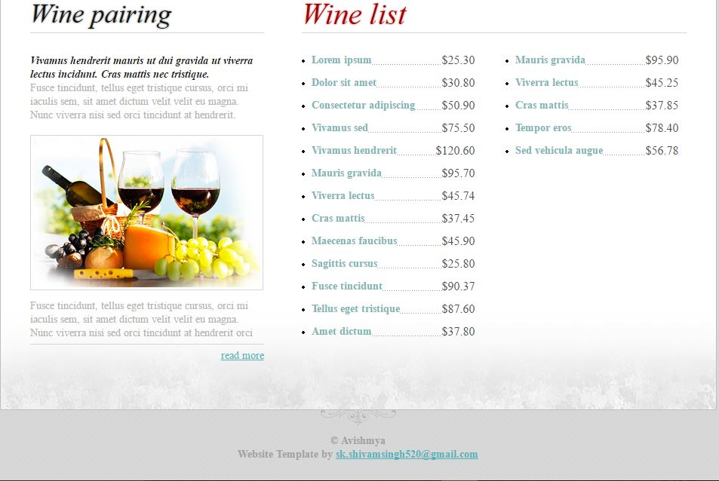

2.CONTACT PAGE:

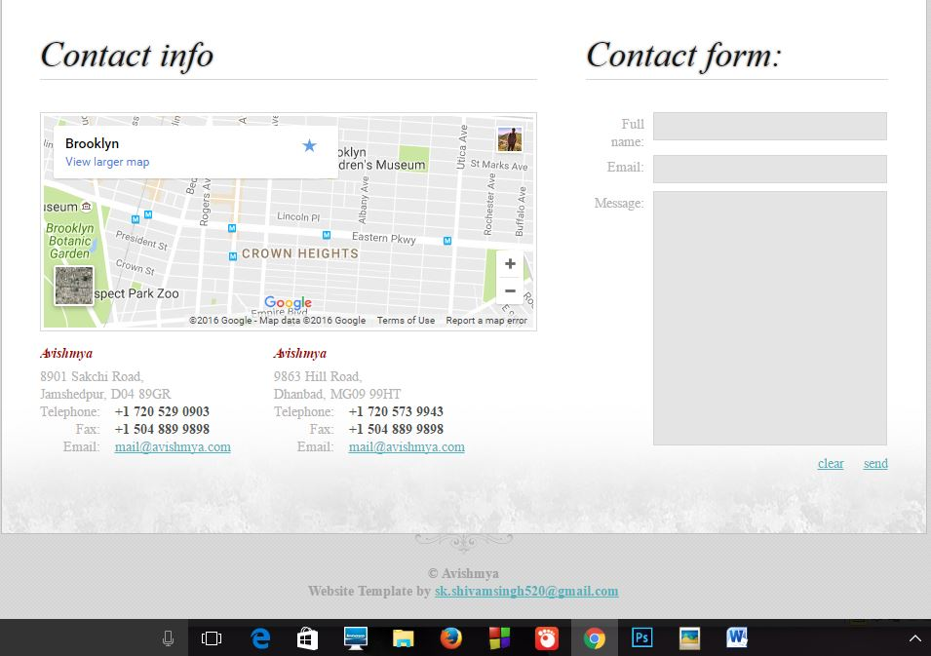

3. LOGIN PAGE:

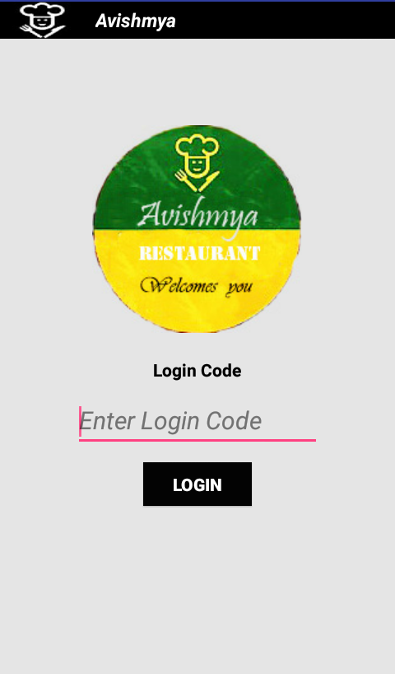

4. MAIN PAGE:

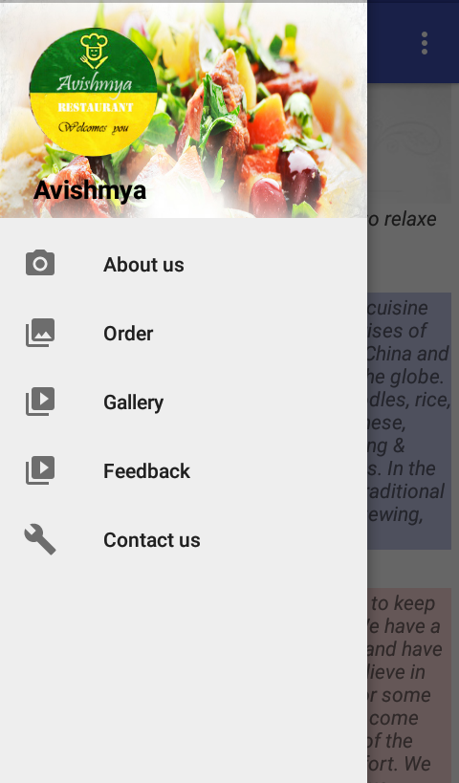

5.COSTUMER DETAILS:

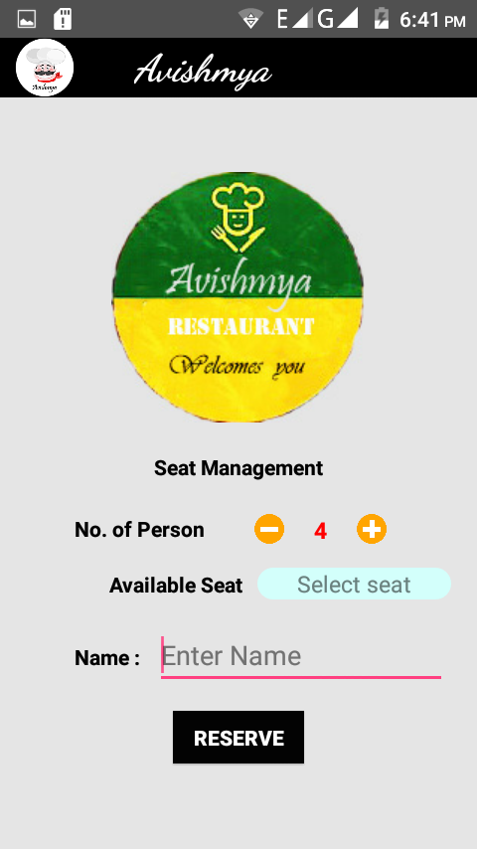

6.ORDER LIST:

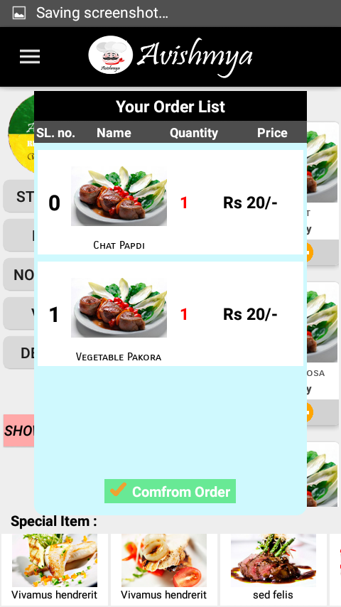

TESTING

Testing is vital to the success of the system. Once the source code has been completed the testing of system is performed to make the system error-free to produce the desired output. System testing makes a logical assumption that if all the parts of the system are correct, the goal of the system will be achieved.
Testing is considered as the Quality Assurance of software products for correctness, completeness, maintainability of software and its related documents. A good test is not redundant. Testing time and resources are limited. There is no point in conducting a test that has same purpose as another test. Every test should have a different purpose.
We have used following some strategies in testing a system:

Code Testing :
The code testing is performed to check the logic of the entire path throughout the software to verify the logic used by the programmer. To perform code test we have developed a series of test cases that is helpful in catching the error if any available through the code
The code test does not depict the failure of system even if they find error or not. It does not give any conclusion whether it has worked according to a specification of system or it can be helpful in implementing the system easily. The code test defines only the code / program logical error of the system.

Specification Testing :
To perform the Specification Testing, we have to examine the specification-documents that are provided by the analyst to verify that whether it works according to all included description about the various condition, type, way of operating and working in known and unknown situations.
Specification-documents include all the conditions, operation and method of working of the system. Thus, specification testing becomes an easy process by just testing according to a given description in it.

Unit Testing :
Unit testing is performed on the independent module. In this testing a single module is tested to verify whether it works according to a specified logic, conditions to make the module error-free.
In unit testing we have created a test cases through which we have tested a single module and then integrated a number of modules and at last all modules are tested with an objective of removing error and the whole system is tested.

System Testing :
System Testing is undertaken to cover find weakness and strength of the system that was not found in earlier testing types. The entire system is tested to detect and correct errors. This includes forced system failure and validation of the total system as it will be by the user in the operational environment.
System testing begins with the lowest volumes of transaction with live data and to the maximum level of all data of the system. The total system is also tested for the recovery and fallback of major failures.

Storage testing :
The specification of the capacity of the system has to be specified by the analyst at design time. The capacity measures in terms of number of records to be handled by the file in which the data to be stored and handled.

Performance Test :
Performance Test is conducted before implementation stage occurs to check the time it takes to produce the output, reports, input, processing sequences of the system.
This test is conducted to determine the time taken to display the various requirements of the user.

Output consideration :
The system is tested for the determination of correct output will it give and it should be according to the user’s requirements.
Various steps involved in output are described below:
- Online-responses: In an online system the output is more vital and it should not cause any hardship to its users. One way to test is to enter the transactions on as many CRT screens as would normally be used in peak hours and note the time taken to respond to each online function to establish a true relationship.
- Volume: This test involves entering the as many records as possible to verify that the hardware and software function effectively.
- Stress testing: The purpose of stress testing is to prove that the system does not malfunction and time factor plays an important role in completing the system within specified time.
- Recovery and security: A forced system failure is intentionally took place to test a backup recovery procedure. Inaccurate data are entered to test the unauthorized user to test the security of the system.
- Usability documentation and procedure: The usability test verifies the user-friendly environment of the system. This relates to normal operating and error-handling procedures of the system.

TEST CASES:

MODULE NAME: CUSTOMER LOGIN PAGE TESTING

SL.NO | TEST CASE | REQUIREMENT | RESULT
1. | LoginID | 1. Same as given by database.  2. Never to be blank. | Passed  Passed

MODULE NAME: CUSTOMER DETAIL PAGE TESTING

SL.NO | TEST CASE | REQUIREMENT | RESULT
1. | USERNAME | 1. Never should be empty.  2. Takes:  a. Alphabets | Passed  Passed
2. | SELECT SEAT | 1. Never should be booked from before. | Passed

LIMITATIONS AND SCOPE FOR FURTHER ENHANSEMENTS

Limitation of the system:
- On the customer side, customer give the feedback to the restaurant which the customer can’t see again.
- There is no direct communication between the customer and manager.
- There is no facility to get an email for the problem.

Future enhancements:
It is not possible to develop a system that makes all the requirements of the customer.
Customer requirements keeps changing as the system is being used. Some of the future enhancements that can be done to his system are:
- There can be direct communication between the customer and the manager.
- There would be a facility to get an email for the problem.
- There would be a facility to get the information about which staff is coming to the customer table and in which time.

CONCLUSION

This is a project for a restaurant to provide better service to their customer. So this project can be called as “digital restaurant”. There are two types of customer who will use this application 1st the customer of the company and 2nd employee of the restaurant who resolves or handle the system.

It can keep the information about the orders, user profile, and manager. It display the good or bad remarks according to the given service to customer.

The part module what I planned is no doubt is completed. I have keep enough provision to complete the entire system. It was not possible to implement the software entirely with in the short span of time.

BIBLIOGRAPHY AND REFERENCE

. Kogent - Black Book – ( Android)

. Youtube - ProgrammingKnowledge (https://www.youtube.com/watch?v=KVlXccl-XBA)

. Thomas A. Powell - HTML: The Complete Reference

